The Yenepoya Institute of Arts, Science, Commerce and Management (YIASCM)



DEPARTMENT OF COMPUTER SCIENCE
LAB MANUAL
Subject: Introduction to Machine Learning (BCA 401P)

Course Facilitator (s): Ms.Arpitha/ Ms.Suzana / Ms.Srijana/ Ms.Jayashrinidhi/Ms Raheema/ Ms Akshatha/Mr Vikyath

PART- A

- Write a program to describe the dataset using pandasdataframe commands and encode the same.
Program Code :
fromsklearn import datasets
importnumpy as np
import pandas as pd
fromsklearn.preprocessing import LabelEncoder, OneHotEncoder
#import the dataset
#from csv file
data=pd.read_csv(r"C:\Users\jackw\Downloads\iris.csv")
#from scikit-learn datasets
iris=datasets.load_iris()
#convert the dataset into pandas dataframe
data=pd.DataFrame(data=np.c_[iris['data'],iris['target']], columns=iris['feature_names']+['target'])
#add the target names or label column to the dataframe
data['target_names']=data['target'].replace(dict(enumerate(iris.target_names)))
#printing top 5 rows
print(data.head())
#display the information iris dataset
data.info()
#describe the iris dataset
print(data.describe())
#Encoding process
#Type I-Label Encoding
#Encoder function
Label_encoder=LabelEncoder()
#Labels
data['target_names']=Label_encoder.fit_transform(data['target_names'])
print(data['target_names'])
#Actual labels
print(Label_encoder.classes_)
#Label count after encoding
print(data['target_names'].value_counts())
#type 2-Label-encoding
#Encoder function
One_hot=OneHotEncoder()
transformed_data=One_hot.fit_transform(data['target_names'].values.reshape(-1,1)).toarray()
print(One_hot.categories_)
#Encode all the lebels in the dataset
transformed_data=pd.DataFrame(transformed_data, columns=['setosa','versicolor','virginica'])
print(transformed_data.head())
OUTPUT: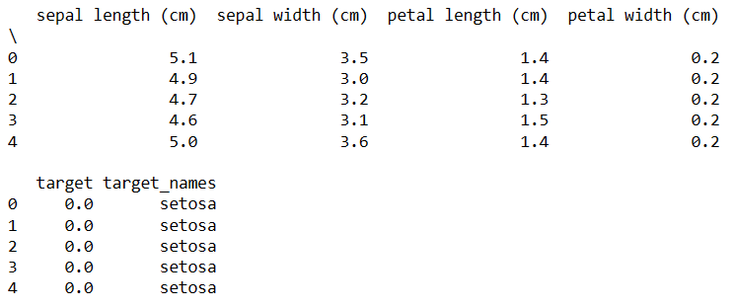

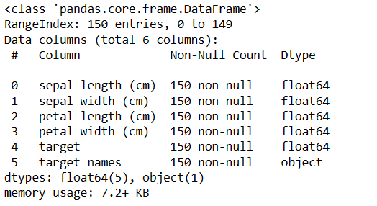

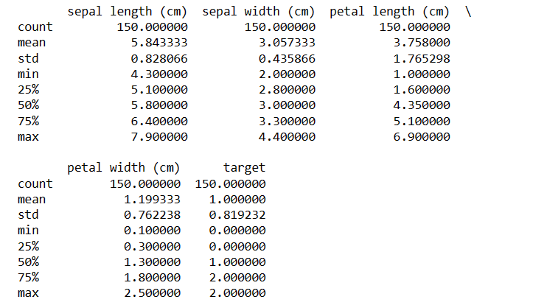

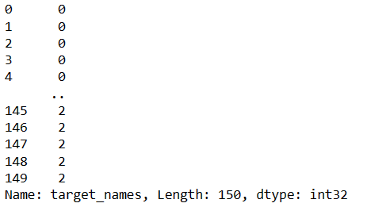

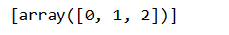

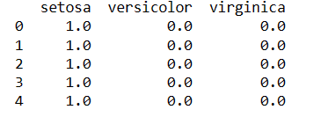

- Write a program to normalize the iris dataset using standardization.
Program Code:
fromsklearn import datasets
import pandas as pd
fromsklearn.preprocessing import StandardScaler, MinMaxScaler
import warnings
iris = datasets.load_iris()
data = pd.DataFrame(data=iris.data, columns=iris.feature_names)
print(data)
print('Average of Feature')
print(data.mean())
print('\nFeature Variance')
print(data.var())
scaler = StandardScaler()
scaler.fit(data)
iris_scaled_std = scaler.transform(data)
iris_df_std_scaled = pd.DataFrame(data=iris_scaled_std, columns=iris.feature_names)
print('Standardized Feature Average')
print(iris_df_std_scaled.mean())
print('\nStandardized Feature Variance')
print(iris_df_std_scaled.var())
scaler = MinMaxScaler()
scaler.fit(data)
iris_scaled_minmax = scaler.transform(data)
iris_df_minmax_scaled = pd.DataFrame(data=iris_scaled_minmax, columns=iris.feature_names)
print('MinMax Scaled Feature Average')
print(iris_df_minmax_scaled.mean())
print('\nMinMax Scaled Feature Variance')
print(iris_df_minmax_scaled.var())
print('\nMinMax Scaled Min Value')
print(iris_df_minmax_scaled.min())
print('\nMinMax Scaled Max Value')
print(iris_df_minmax_scaled.max())
OUTPUT:
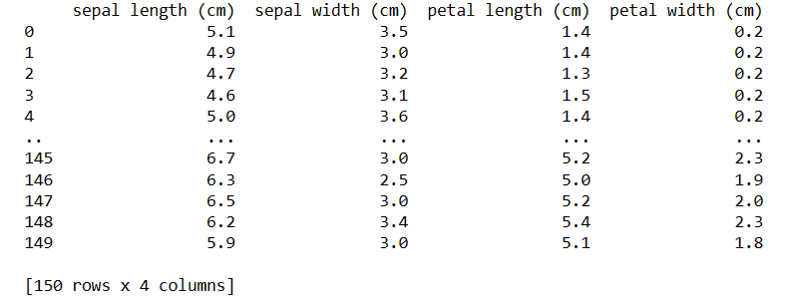

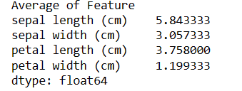

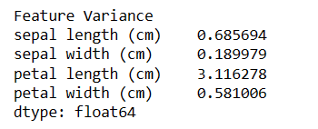

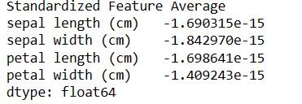

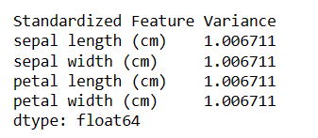
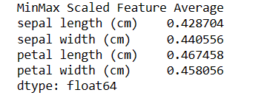
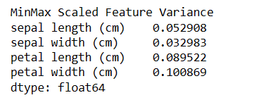

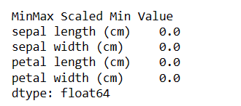

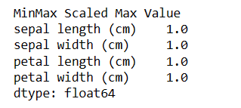

- Write a program to impute the missing values and perform discrete transformation on the iris dataset.
Program Code:
fromsklearn import datasets
importnumpy as np
import pandas as pd
fromsklearn.preprocessing import KBinsDiscretizer
fromsklearn.impute import SimpleImputer
import warnings
iris = datasets.load_iris()
data = pd.DataFrame(data=iris.data, columns=iris.feature_names)
print(data)
imputer = SimpleImputer(missing_values=np.nan, strategy='mean')
print(imputer)
imputer = imputer.fit(data)
imputed_dataset = imputer.transform(data)
print(imputed_dataset)
iris_quantile_transform = KBinsDiscretizer(n_bins=10, encode='ordinal', strategy='quantile')
quantile_transformed_data = iris_quantile_transform.fit_transform(data)
print(pd.DataFrame(quantile_transformed_data))
iris_uniform_transform = KBinsDiscretizer(n_bins=10, encode='ordinal', strategy='uniform')
uniform_transformed_data = iris_uniform_transform.fit_transform(data)
print(pd.DataFrame(uniform_transformed_data))
OUTPUT:
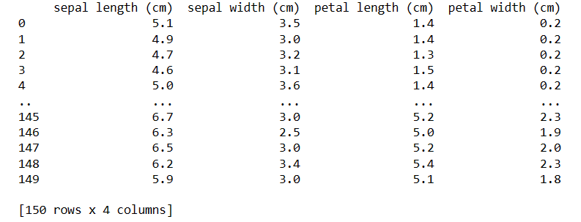

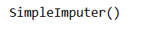

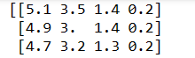

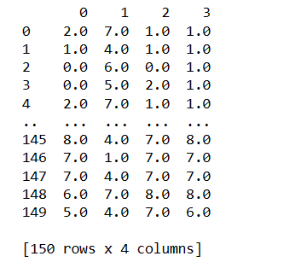

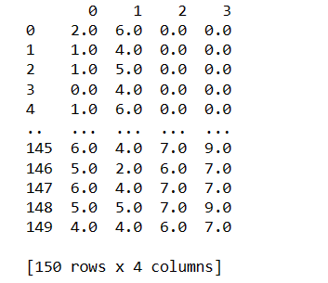

- Write a program to visualize the iris dataset using sepal and petal values.
Program Code:
fromsklearn import datasets
importnumpy as np
import pandas as pd
importmatplotlib.pyplot as plt
iris = datasets.load_iris()
data = pd.DataFrame(data=iris.data, columns=iris.feature_names)
print(data)
fig, ax = plt.subplots() # Assign fig here
scatter = ax.scatter(iris.data[:, 0], iris.data[:, 1], c=iris.target)
ax.set(xlabel=iris.feature_names[0], ylabel=iris.feature_names[1])
ax.legend(scatter.legend_elements()[0], iris.target_names, loc="lower right", title="Classes")
plt.show()
fig, ax = plt.subplots()
scatter = ax.scatter(iris.data[:, 0], iris.data[:, 1], c=iris.target)
ax.set(xlabel=iris.feature_names[2], ylabel=iris.feature_names[3])
ax.legend(scatter.legend_elements()[0], iris.target_names, loc="lower right", title="Classes")
plt.show()
OUTPUT:
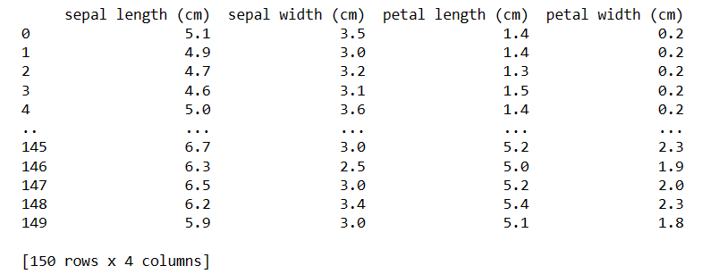
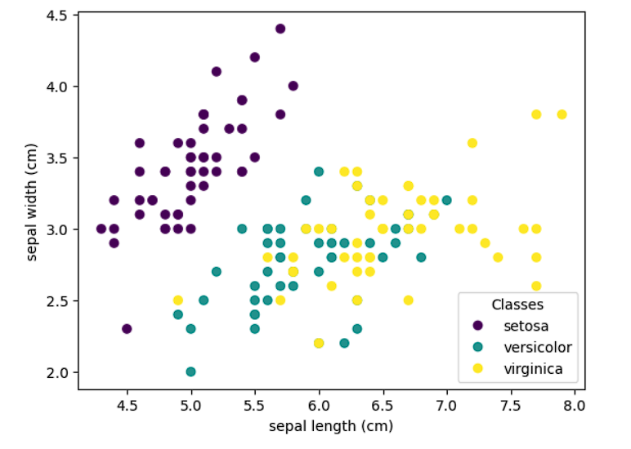
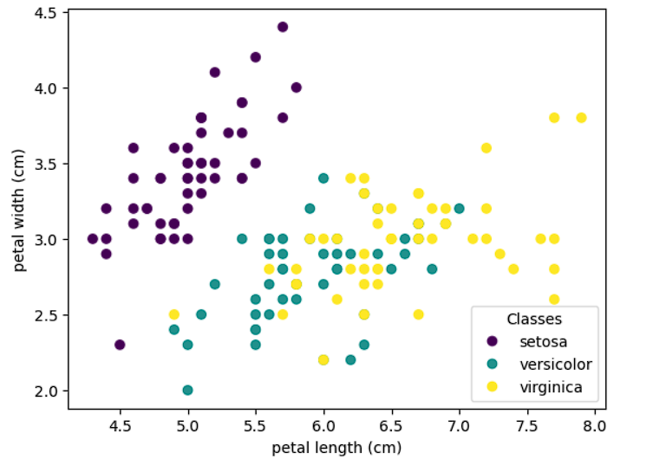

- Write a program to apply principal component analysis on the iris dataset.
Program Code:
fromsklearn import datasets, decomposition
importnumpy as np
import pandas as pd
importmatplotlib.pyplot as plt
import mpl_toolkits.mplot3d
iris = datasets.load_iris()
data = pd.DataFrame(data=iris.data, columns=iris.feature_names)
X = data
y = iris.target
print(data)
fig = plt.figure(1, figsize=(4, 3))
plt.clf()
ax = fig.add_subplot(111, projection="3d", elev=48, azim=134)
ax.set_position([0, 0, 0.95, 1])
plt.cla()
pca = decomposition.PCA(n_components=3)
pca.fit(X)
X = pca.transform(X)
print(X)
for name, label in [("Setosa", 0), ("Versicolour", 1), ("Virginica", 2)]:
ax.text3D(
X[y == label, 0].mean(),
X[y == label, 1].mean() + 1.5,
X[y == label, 2].mean(),
name,
horizontalalignment="center",
bbox=dict(alpha=0.5, edgecolor="w", facecolor="w"), )
y = np.choose(y, [1, 2, 0]).astype(float)
ax.scatter(X[:, 0], X[:, 1], X[:, 2], c=y, cmap=plt.cm.nipy_spectral, edgecolor="k")
ax.xaxis.set_ticklabels([])
ax.yaxis.set_ticklabels([])
ax.zaxis.set_ticklabels([])
plt.show()
OUTPUT:
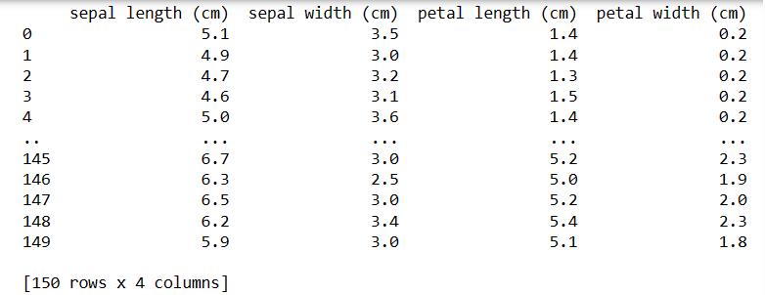

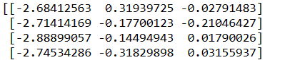

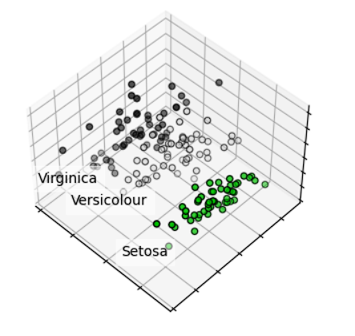

PART- B

- Write a program to apply linear regression on the iris dataset and find the error of prediction.
Ans: from sklearn import datasets, decomposition
import pandas as pd
fromsklearn.linear_model import LinearRegression
fromsklearn.model_selection import train_test_split
fromsklearn.metrics import mean_squared_error
importmatplotlib.pyplot as plt
iris = datasets.load_iris()
X = iris.data
y = iris.target
X_train, X_test, y_train, y_test = train_test_split(X, y, test_size=0.2, random_state=42)
model = LinearRegression()
model.fit(X_train, y_train)
y_pred = model.predict(X_test)
mse = mean_squared_error(y_test, y_pred)
print("Mean Squared Error:", mse)
OUTPUT:

- Write a program to apply logistic regression on the iris dataset.
Ans: from sklearn import datasets, decomposition
import pandas as pd
fromsklearn.linear_model import LogisticRegression
fromsklearn.model_selection import train_test_split
fromsklearn.metrics import mean_squared_error
iris = datasets.load_iris()
data = pd.DataFrame(data=iris.data, columns=iris.feature_names)
X = data
y = iris.target
X_train, X_test, y_train, y_test = train_test_split(X, y, test_size=0.2, random_state=42)
logreg = LogisticRegression(solver='lbfgs', penalty='l2', max_iter=10000)
logreg.fit(X_train, y_train)
y_pred = logreg.predict(X_test)
mse = mean_squared_error(y_test, y_pred)
print("Mean Squared Error:", mse)
accuracy = logreg.score(X_test, y_test)
print("Logistic regression Accuracy:", accuracy)
OUTPUT:
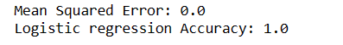

- Write a program to apply support vector machine classifier on the iris dataset and generate a confusion matrix of the classifier.
Ans: from sklearn import datasets, decomposition
import pandas as pd
fromsklearn.model_selection import train_test_split
fromsklearn.svm import SVC
fromsklearn.metrics import confusion_matrix
fromsklearn.model_selection import cross_val_score
iris = datasets.load_iris()
X = iris.data
y = iris.target
X_train, X_test, y_train, y_test = train_test_split(X, y, test_size=0.2, random_state=42)
SVM_classifier = SVC(kernel='linear', random_state=0)
SVM_classifier.fit(X_train, y_train)
accuracy = cross_val_score(estimator=SVM_classifier, X=X_train, y=y_train, cv=10)
print("Accuracy: {:.2f} %".format(accuracy.mean()*100))
y_pred = SVM_classifier.predict(X_test)
SVM_cm = confusion_matrix(y_test, y_pred)
print("The confusion matrix is:")
print(SVM_cm)
OUTPUT:
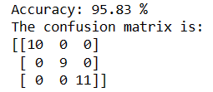

- Write a program to apply naïve bayes classifier on the iris dataset.
Ans: from sklearn import datasets, decomposition
import pandas as pd
fromsklearn.model_selection import train_test_split
fromsklearn.naive_bayes import GaussianNB
fromsklearn.metrics import accuracy_score
iris = datasets.load_iris()
X = iris.data
y = iris.target
X_train, X_test, y_train, y_test = train_test_split(X, y, test_size=0.3, random_state=42)
model = GaussianNB()
model.fit(X_train, y_train)
y_pred = model.predict(X_test)
accuray = accuracy_score(y_pred, y_test)
print("Accuracy score is:", accuray)
OUTPUT:

- Write a program to apply k-means clustering on the iris dataset.
Ans: from sklearn import datasets, decomposition
import pandas as pd
fromsklearn.model_selection import train_test_split
fromsklearn.cluster import KMeans
importmatplotlib.pyplot as plt
iris = datasets.load_iris()
X = iris.data
y = iris.target
X_train, X_test, y_train, y_test = train_test_split(X, y, test_size=0.3, random_state=42)
kmeans = KMeans(n_clusters = 3, init = 'k-means++', max_iter = 300, n_init = 10, random_state = 0)
y_kmeans = kmeans.fit_predict(X)
plt.scatter(X[y_kmeans == 0, 0], X[y_kmeans == 0, 1], s = 100, c = 'purple', label = 'Iris-setosa')
plt.scatter(X[y_kmeans == 1, 0], X[y_kmeans == 1, 1], s = 100, c = 'orange', label = 'Iris-versicolour')
plt.scatter(X[y_kmeans == 2, 0], X[y_kmeans == 2, 1], s = 100, c = 'green', label = 'Iris-virginica')
plt.scatter(kmeans.cluster_centers_[:, 0], kmeans.cluster_centers_[:,1], s = 100, c = 'red', label = 'Centroids')
plt.legend()
plt.show()
OUTPUT:
